USDA Foreign Agricultural Service
GAIN Report

Template Version 2.09

Global Agriculture Information Network

Required Report - public distribution
Date: 01/07/2004
GAIN Report Number: SF4001
0000
South Africa, Republic of
Fresh Deciduous Fruit
Annual
2004

Approved by:
Scott Reynolds
U.S. Embassy
Prepared by:
Patricia Mabiletsa

Report Highlights:
South Africa's 2003/04 fresh deciduous fruit production is expected to increase by about 4% because of good rains and temperatures from the last season. Apple production will rise by 3%, pears by 15% and a slight decrease (2%) is expected for tablegrapes. The industry is closely adhering to the export requirements on food safety, traceability and EurepGAP practices. South Africa's currency is continuing to strengthen against the Dollar, and is currently trading at about R6.50 to a US Dollar in early January 2004.

Includes PSD Changes: Yes
Includes Trade Matrix: Yes
Semi-Annual Report
Pretoria [SF1]
[SF]
Table of Contents
Executive Summary 3
Production 4
Production Subcategory 5
Consumption 7
Consumption Subcategory 7
Trade 7
Trade Subcategory 8
Stocks 10
Stocks Subcategory 10
Policy 10
Policy Subcategory 11
Marketing 11
Marketing Subcategory 11

Executive Summary

South Africa’s 2003/04 fresh deciduous fruit production is expected to increase by 4% from last year. The Western Cape is experiencing a hot and dry summer period. The winter season produced low rainfall that did not fill the reservoirs.

The impact of the dry and hot weather around September and October, and the combination of both heat and cold spells during period of blossoming and fruit setting, may have negatively off-set the total crop, especially the tablegrapes.
In Grasbouw/Elgin area of the Western Cape, hail and rainfalls at harvest time may have negatively impacted the export quality for apples.

The 2003/4 fruit industry expects a generally low production of tablegrapes because of heavy frost damage around the Orange River and parts of the Northern province. However, a very good pear crop is expected, while the apple production is expected to increase by 3%.

Exports are also expected to decrease significantly by 21% because of increasing export costs, a decrease in quality of apples for export caused by hail damage, and decrease in total grapes production. The above factors are therefore expected to lead to more fruit being consumed domestically.
Improvement of the value of the Rand is unfortunately not favoring exporters.

Production

FRESH APPLES

The table below shows actual figures on apple production, exports, domestic consumption and processing trends for a period of three years.

YEARS | 2000 | 2001 | 2002
PRODUCTION | 573,966 | 567,005 | 584,339
CONSUMPTION | 155,538 | 148,525 | 158,339
EXPORTS | 208,510 | 244,819 | 257,583
PROCESSING | 209,918 | 173,661 | 168,072
Source: NDA

FRESH PEARS

Below is a table that shows the actual figures on pear production, exports, domestic consumption and processing trends for a period of three years.

YEARS | 2000 | 2001 | 2002
PRODUCTION | 307,516 | 260,689 | 320,040
CONSUMPTION | 60,379 | 55,890 | 53,766
EXPORTS | 95,540 | 90,405 | 119,076
PROCESSING | 151,597 | 114,394 | 147,198
Source: NDA

FRESH TABLEGRAPES

South Africa’s major production areas for tablegrapes are the Hex River valley, Limpopo and Mpumalanga. Limpopo and Mpumalanga exports mainly to the Southern hemisphere, while the Hex River valley serves Northern hemisphere. Total average area planted to tablegrapes around the Hex River valley in the Orange River region amounts to about 8,000 Ha. The region is prone to severe hailstorms especially during the harvesting season, which starts at the beginning of November (week 45), and reaches a peak in mid-December (week 50). The area exports mainly to the Northern hemisphere countries. 2003/4 exports from this region are expected at about 60,000 MT.

The table below shows actual figures for tablegrapes production, exports, domestic consumption and processing trends for a period of four years.
YEARS | 2000 | 2001 | 2002
METRIC UNITS | TONS | TONS | TONS
#PRODUCTION | 1,454,867 | 1,328,193 | 1,384,685
CONSUMPTION | 22,929 | 24,555 | 26,623
EXPORTS | 185,242 | 181,834 | 207,279
PROCESSING | 1,246,695 | 1,121,804 | 1,150,783
#: Total grape production, subdivided as follows:
YEARS | 2000 | 2001 | 2002
Metric Units | Tons | Tons | Tons
Fresh t/grapes | 356,594 | 351,686 | 368,583
Pressed t/grapes | 1,098,273 | 976,507 | 1,016,102
TOTAL PRODN. | 1,454,867 | 1,328,193 | 1,384,685
Source: NDA

Production Subcategory

PSD FRESH APPLES

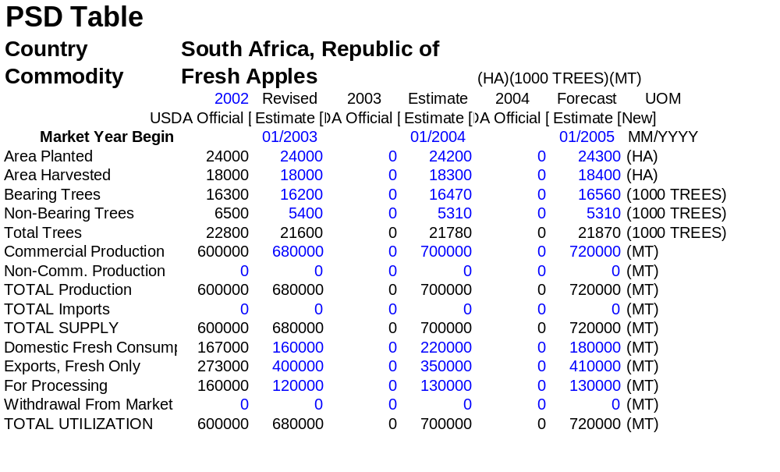

PSD FRESH PEARS

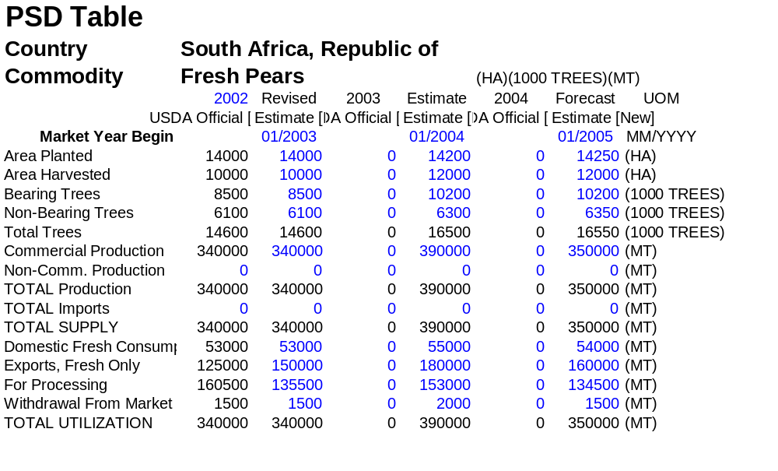

PSD FRESH TABLEGRAPES

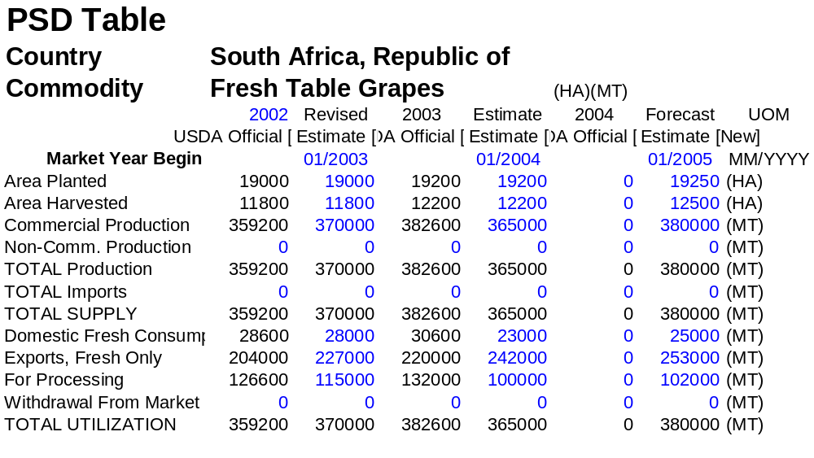

Consumption
In 2003/04, the deciduous fruit farmers are expected to increase the local prices for fresh fruit, especially the tablegrapes, to buffer the losses incurred from the export markets because of both increasing competition and the appreciated value of the Rand. Other expectations are more fruit will be sold to the processors than the fresh markets as a result of both the local market’s inelastic demand for fresh fruit, and the products’ limited lifespan for storage. However, it is likely that the local fresh market may end up with a glut of apples and pears because these products lack a unified structure to control supply.

Consumption Subcategory
None

Trade

While Europe is still a major market for the South African fruit industry, the industry is planning to reduce its market share in that market in 2003/4 and to increase supply to both the domestic and to new markets, namely Russia, China and Japan.
Increase in commodity prices is also likely, as the industry tries to buffer the impact of the strong Rand.

Brazil is gradually becoming South Africa’s export competitor in the Europe for ‘early-season’ grapes. Other competitors gaining momentum are Namibia, India, China and Chile.

Trade Subcategory

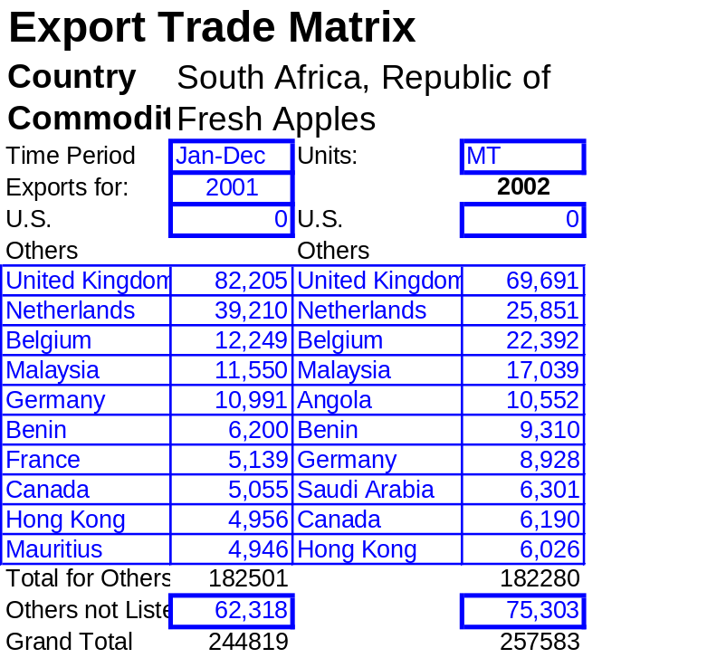

In 2002, Angola was South Africa’s 5th largest fresh apple export market with supply more than doubling from 4,012 MT of the previous season. Figures from January to September 2003 show a decline to about 3,573 MT compared to the 9,705 MT of the same period in 2002.
Exports to Saudi Arabia also increased in 2002 and are expected to remain among South Africa’s 10 major export markets, as reflected by the January -September 2003 figures at about 6,918 MT from 6,237 MT a year earlier.
South Africa does not export fresh apples to the United States.

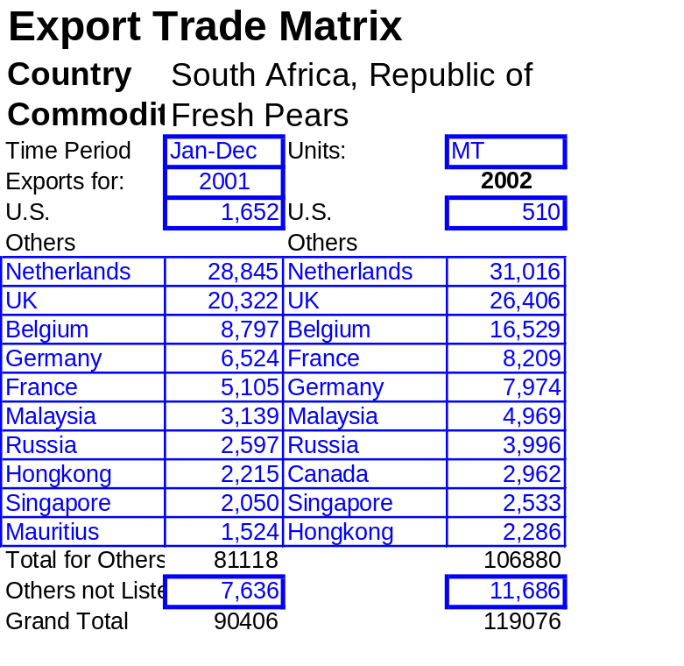In 2002, South Africa drastically reduced the fresh pear exports (69%) to the United States, although the January-September 2003 figures indicates an expected improvement of about 15% compared to the same period of last year. Exports to Canada more than doubled in 2002, with Canada ranking as South Africa’s 8th largest fresh pears export market, and is expected to maintain the same level at a slight improvement to 2,987 MT (last year, 2,961) in January-September 2003.
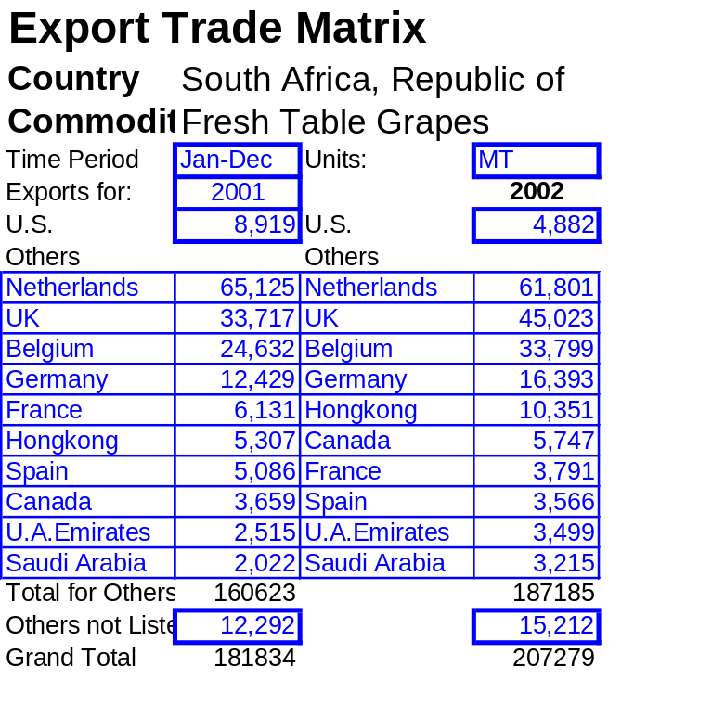

Russia is gradually becoming South Africa’s growing export market, from no tablegrapes export in 2000, growing massively to reach 1,450 MT in 2002 because of the new Free Trade Agreement between the two countries. In 2003, tablegrape exports to Russia have confirmed to grow by about 76%, from 1,450 MT (Jan-Sept) in 2002 to 2,554 MT the same period.

Export figures for 2003

COMMODITY | Jan-Sept (MT)* | Jan-Dec (MT)#
APPLES | 312,897 | 400,000
PEARS | 117,698 | 150,000
T/GRAPES | 176,528 | 227,000
*Source Dept. of Customs & Excise, # PPECB

Stocks
none

Stocks Subcategory
None

Policy

In 2002, South Africa’s National Department of Agriculture enforced a new legislation to ensure compliance with international food safety protocols.
South African farmers are adhering to the export market standards on food safety, traceability and EurepGAP.

REGULATIONS AND REQUIREMENTS

South Africa maintains strict grading standards and requirements for quality exports of stonefruit, tablegrapes, and pomefruit destined for the EU and US.
The National Department of Agriculture’s Directorate of Plant Health and Quality conducts standard approval tests for all imported agricultural bio-controlled products.
Registration for bio-control products requires specification of the technical grade active ingredients for microbial Pest Control Agent (MPCA) and product standardizing.
The Acts-Fertilizers, Farm Feeds, Agricultural Remedies and Stock Remedies Act (1947), and the Agricultural Remedies Act (Act 15 of 1973); regulates label specifications, use, storage and disposal.
The Agricultural Pests Act of 1983 control illegal importation of exotic species of entomopathogenic microbes.

TRACEABILITY

Traceability using human readable coding, mainly used for food safety and phytosanitary matters, is another statutory requirement in South Africa.
The deciduous fruit industry and the International Fresh Produce Traceability (IFPT) project team are currently establishing pilots within the country.

LABELING

The Agricultural Production Standards Act regulates the Markings and Labeling of exports from SA.

EUROGAP PROTOCOLS

South African deciduous fruit industry is implementing EuroGAP protocols on production units, HACCP and ISO in pack-houses as required by European Union importing countries.

Policy Subcategory

Marketing

In 2003/4, South Africa’s fruit industry plans to expand its export markets to the Far East.
The fruit farmers are more skeptical about the strengthening of the Rand, most especially for
mass-produced products like Golden Delicious apples, which are likely to flood the local markets and in turn result in lower producer returns.

Marketing Subcategory
none

